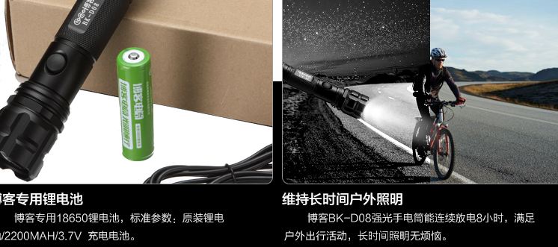

|  |  |  |  |  |
| --- | --- | --- | --- | --- |
| HS Code | Product Name | Price($) | Quantity | Total Price($) |
| [**85139010.00**](http://www.i5a6.com/hscode/detail/8513901000) | LED手电筒配件(筒身) / LED Flashlight accessories | 2 | 13 | 26 |

**Product List:**

13 x Led flashlight accessories. (Body pipe)

**From:**

General Manager: Vincent Chen

Company Name: HangZhou NaKu Technology Co., Ltd

Company Address: Binjiang District PuYan Xipu Road 1503# Binke Building,Hangzhou,Zhejiang,China

Post code: 310053

Mobile: 0086-15967129903

**To:**

Moklis Ali,333 ,Buntingford, Hertfordshire,United Kingdom   
Post code:SG99EA

Tel: +44 17632713